Pacman The Change of appearance

When someone talks about Pacman today, everyone knows that this yellow circle is meant where a piece is missing. But in the past, it was not a yellow circle but a white one consisting of pixels. Just like the ghosts were all blue. Nowadays with today‘s technology, the game is much more elaborated you have beautiful shapes and you don’t see the pixels as strong anymore. For example you can see two pictures one from the old Version and one from the new Version. Also there are more than two Versions existing for example the Championship edition or the edition called “Ms. Pacman”, but only the two below represent the original Pacman.

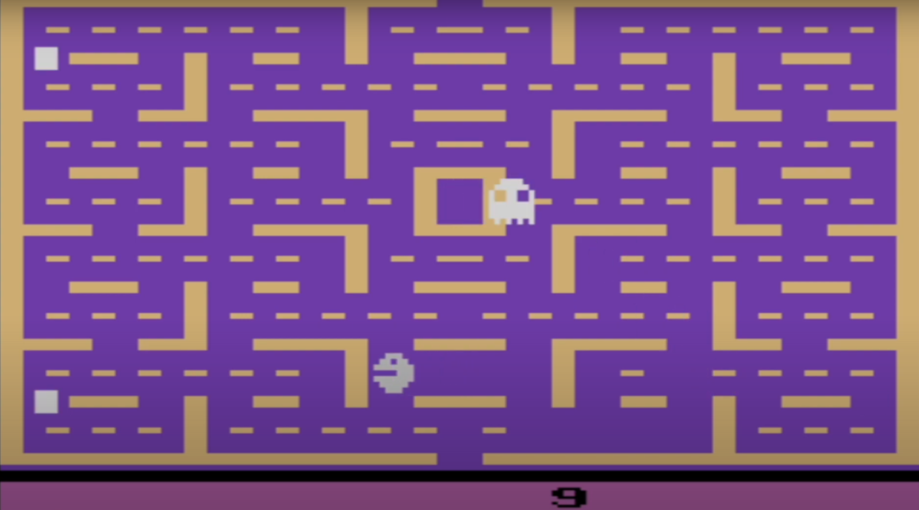

Old Version

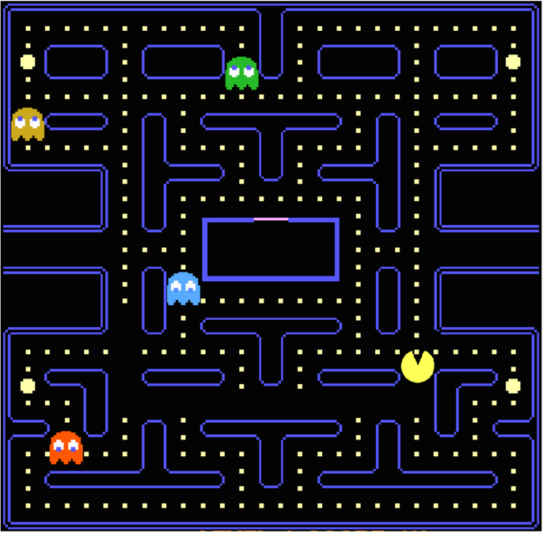

New Version